Proforma 4

Undertaking from the UG/PG student(s) while submitting his/her final dissertation to his respective institute

Ref. No. _17070124007

17070124004
17070124003
17070124019
I / We, the following student(s)

 | Sr. | Sequence of | Students name | Name of the Institute & |  |  |  | Email & Mobile
 | No. | students |  | Place
 |  | names on a
 |  | dissertation
 | 1. | 1st student | Akul Bhardwaj | SIT, Pune |  |  |  | akul.bhardwaj@sitpune.edu.in
 |  |  |  |  | 9468961201
 | 2. | 2nd student | Aditya Ranjan | SIT, Pune |  | aditya.ranjan@sitpune.edu.in
 |  |  |  |  | 8160961578
 | 3. | 3rd student | Abhas Gupta | SIT, Pune |  | abhas.gupta@sitpune.edu.in
 |  |  |  |  | 8085825050
 | 4. | 4th student | Deeptanshu Panthi | SIT, Pune |  |  |  | deeptanshu.prasad@sitpune.edu.in
 |  |  |  |  | 7694989853
Note: Put additional rows in case of more number of students

hereby give an undertaking that the dissertation entitled Final year project on Covid-19 Detection Using Chest X-Rays has been checked for its Similarity Index/Plagiarism through Turnitin software tool; and that the document has been prepared by me/us and it is my/our original work and free of any plagiarism. It was found that:
1. | The Similarity Index (SI) was: |  | 0 %
 | (Note: SI range: 0 to 10%; if SI is >10%, then authors cannot communicate ms; attachment
 | of SI report is mandatory)
2. | The ethical clearance for research work conducted obtained from: |  | N/A
 | (Note: Name the consent obtaining body; if ‘not appliable’ then write so)
3. | The source of funding for research was: |  | N/A
 | (Note: Name the funding agency; or write ‘self’ if no funding source is involved)
4. | Conflict of interest: |  |  | No
 | (Note: Tick | whichever is applicable)
5. | The material (adopted text, tables, figures, graphs, etc.) as has been |  |  | Yes
 | obtained from other sources, has been duly acknowledged in the
 | manuscript:
 | (Note: Tick | whichever is applicable)

In case if any of the above-furnished information is found false at any point in time, then the University authorities can take action as deemed fit against all of us.

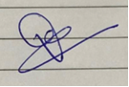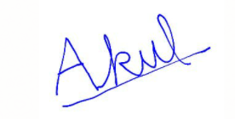

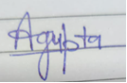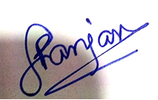

Akul Bhardwaj
Aditya Ranjan
Abhas Gupta
Deeptanshu Panthi

Full Name &

Signature of the student(s)

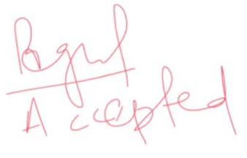

Prof. Poorva Agrawal
Prof. Gagandeep Kaur

Name &

Signature of SIU Guide/Mentor

Date: 29th May 2021
Place: PUNE Endorsement by Academic Integrity Committee (AIC)

Note: It is mandatory that the Similarity Index report of plagiarism (only first page) should be appended to the UG/PG dissertation.

Plagiarism Report:-

